EE5907 PATTERN RECOGNITION
AY 2024/25 SEMESTER 1
CA2 REPORT

Qi Ninghan
A0298690J
Department of Electrical and Computer Engineering
National University of Singapore

20/11/2024
Contents
1 Data preprocessing 1
2 Principal Component Analysis 1
2.1 Feature extraction and visualization 1
2.2 Classification accuracy 2
3 Linear Discriminant Analysis 3
3.1 Visualization 3
3.2 Classification accuracy 5
4 Gaussian Mixture Model 5
5 Convolutional Neural Network 7
6 Summary 9

1 Data preprocessing
In this project, I chose 25 categories of face images from the entire CMU PIE dataset, and the precise categories are shown in Table 1.1. These images are put into a folder called ‘data’. My selfies are put into a folder called ‘selfie’.
Table 1.1 Categories of CMU PIE dataset
Categories
1 | 3 | 5 | 8 | 10
13 | 14 | 16 | 19 | 21
25 | 27 | 30 | 37 | 39
41 | 44 | 46 | 49 | 51
54 | 56 | 61 | 63 | 67
There are 170 images for each category, so there are 4250 images in these categories. Adding on my selfies, there are 4260 samples available. After splitting the samples into training and testing sets with a ratio of 70% and 30%, there are 2982 samples in the training set and 1278 samples in the testing set. After choosing the 26 categories, I standardized the data to a mean of 0 and a standard deviation of 1.

2 Principal Component Analysis

2.1 Feature extraction and visualization
In this part, 500 sample images are randomly selected from the training set, which are then processed with PCA to 2 and 3 dimensions. For the 2D and 3D cases, the visualization of the data in the corresponding feature space is shown in Figure 2.1 and 2.2, where the selfies are highlighted in red color.
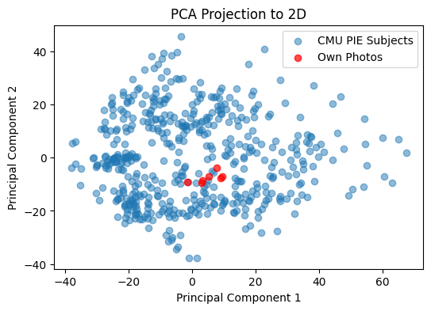
Figure 2.1 PCA 2D visualization
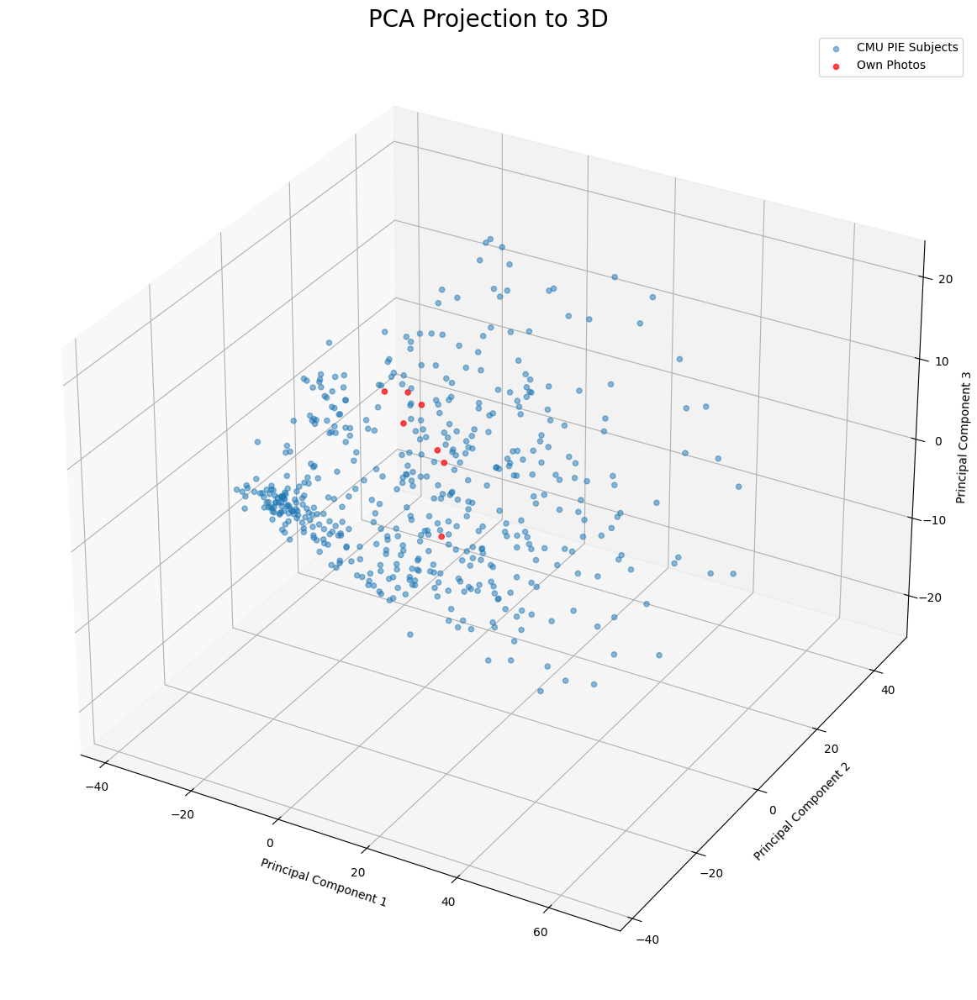
Figure 2.2 PCA 3D visualization
In both 2D and 3D illustrations, the samples from different categories are close and quite mixed up with each other, with their principal components ranging from -40 to 60 and -40 to 40. Moreover, in both the 2D and 3D cases, the selfies’ PCs are mixed with other images which means that my selfies’ features lie in the range of the whole dataset’s components. The following figure shows the three eigenfaces used for dimensionality reduction.
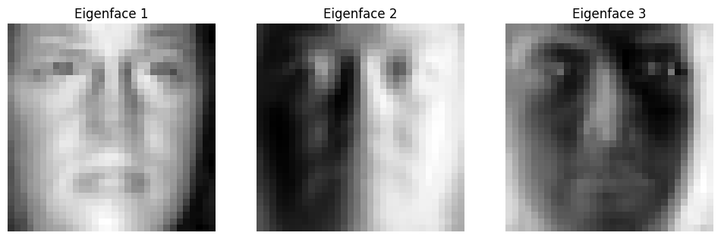
Figure 2.3 Eigenfaces

2.2 Classification accuracy
For the classification, the dimensionalities are reduced to 40, 80 and 200 respectively and a K-Nearest-Neighbor classifier is used with K=1. Table 2.1 illustrates the classification performance regarding different dimensions on the CMU PIE dataset and my selfies.
Table 2.1 PCA test accuracy
Dimensions | Dataset | Test Accuracy
40 | CMU PIE | 94.67%
 | Selfie | 100%
80 | CMU PIE | 96.16%
 | Selfie | 100%
200 | CMU PIE | 96.71%
 | Selfie | 100%
As can be seen from the table, with dimensions increasing, the test accuracy on the CMU PIE dataset also increases a little bit, from 94.67% to 96.71%, all of which are relatively good results as only below 10% of the images are misclassified. For my selfie dataset, the accuracy soars to 100%, which means that it classifies all my test selfies correctly. This is a rather good result, however, there’s a potential risk of overfitting, because the model may have learned specific patterns or features unique to the selfie rather than generalizable characteristics.
The gradual increase in test accuracy on the CMU PIE dataset as the dimensionality rises shows that higher-dimensional feature representations capture more information, which contributes to better discrimination between different classes. This improvement demonstrates that using more principal components enhances model performance, especially on complex datasets. However, the perfect classification accuracy on the selfie dataset suggests that this dataset is less complex compared to the CMU PIE dataset. This high accuracy implies that my selfies are easily distinguishable from other images.

3 Linear Discriminant Analysis

3.1 Visualization
In this part, 500 sample images are randomly selected from the training set, which are then processed with LDA to 2, 3 and 9 dimensions. For the 2D and 3D cases, the visualization of the data in the corresponding feature space is shown in Figure 3.1 and 3.2, where the selfies are also highlighted in red color.

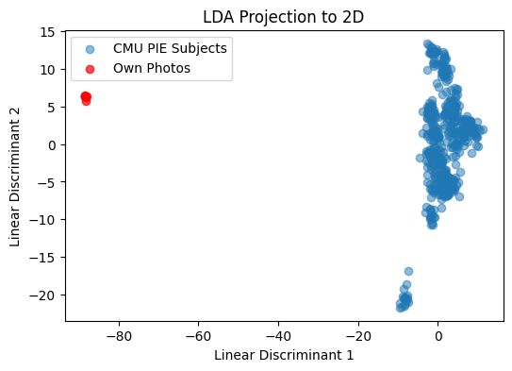
Figure 3.1 LDA 2D visualization
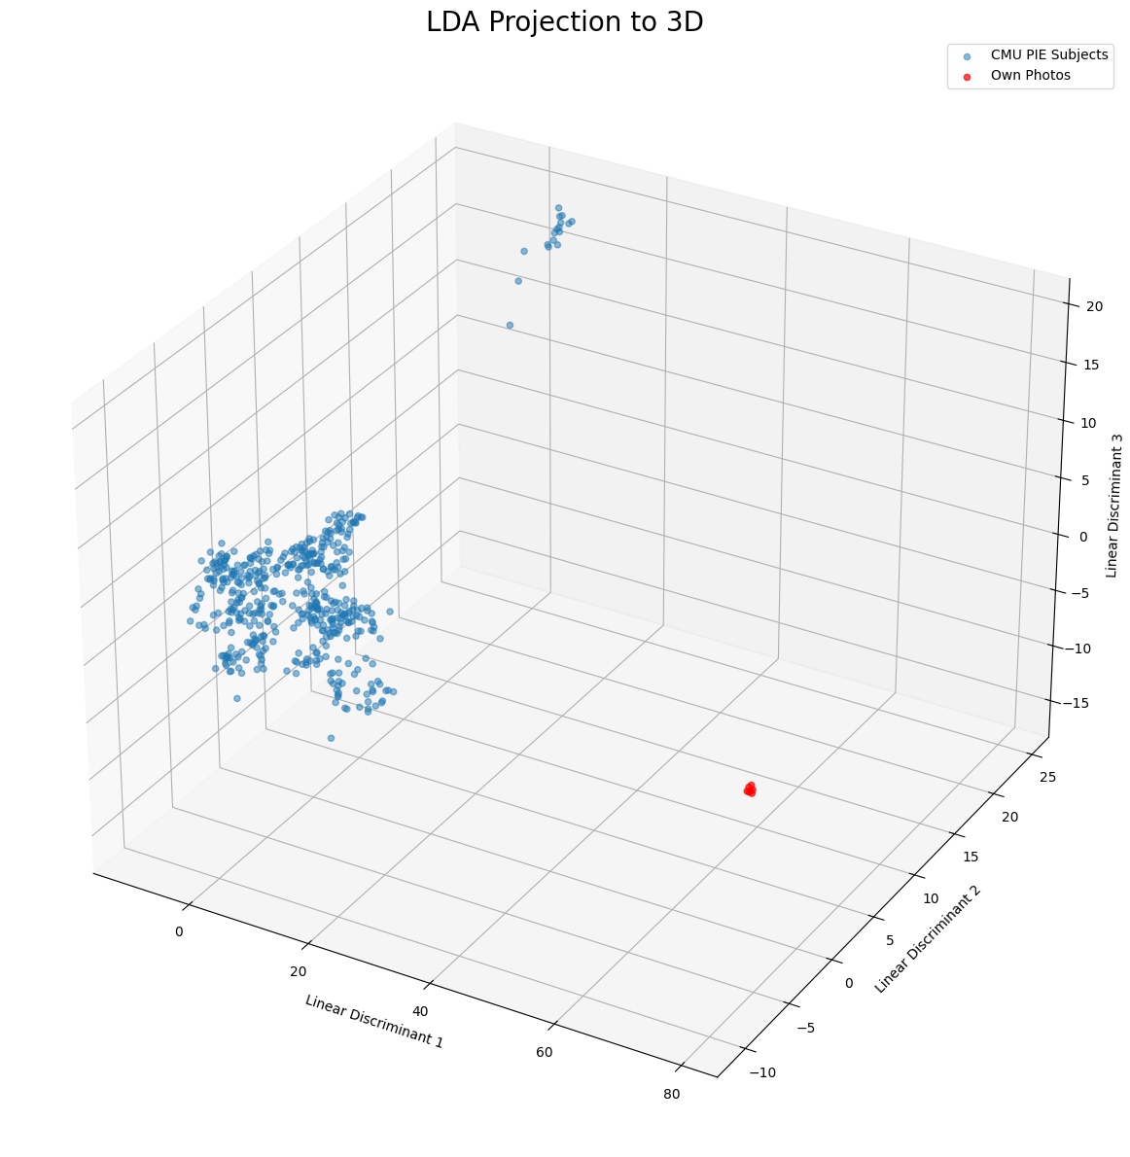
Figure 3.2 LDA 3D visualization
In both 2D and 3D illustrations, the samples from different categories except selfies are close and quite mixed up with each other, with their linear discriminants ranging from -20 to 20 and -80 to 0. However, in both the 2D and 3D cases, the selfies are quite apart from other images which means that my selfies’ linear discriminants lie out of the range of the whole dataset. LDA maximizes the separation between classes while minimizing within-class variance. In LDA projection space, selfies and other categories are better
separated because LDA takes class labels into account and aims to maximize class separation. This explains why selfies can be distinctly separated from other categories in LDA, while they tend to be mixed up in PCA.

3.2 Classification accuracy
For the classification, the dimensionalities are 2, 3 and 9 respectively and a K-Nearest-Neighbor classifier is used with K=1. Table 3.1 illustrates the classification performance regarding different dimensions on the CMU PIE dataset and my selfies.
Table 3.1 LDA test accuracy
Dimensions | Dataset | Test Accuracy
2 | CMU PIE | 22.59%
 | Selfie | 33.33%
3 | CMU PIE | 45.02%
 | Selfie | 33.33%
9 | CMU PIE | 91.22%
 | Selfie | 33.33%
As can be seen from the table, with dimensions increasing, the test accuracy on the CMU PIE dataset also increases dramatically, from 22.59% to 91.22%. At first, the result doesn’t seem very good, but after increasing the dimension to 9, the accuracy is considerable. For my selfie dataset, the accuracy remains at 33.33%, which means that LDA doesn’t work so well on my selfies, potentially because the selfies lack distinct class-based features that LDA can distinguish, or they don’t exhibit the same variance structure as the CMU PIE dataset. The low accuracy on selfies indicates that LDA’s class-separating capability doesn’t generalize well to my dataset, highlighting the limitations of the method in cases where the data lacks some clear and class-specific patterns. The disparity between the results for the CMU PIE dataset and the selfie dataset shows that while LDA is suitable for datasets with well-separated classes, it struggles with more uniform data that don’t align with its assumptions.

4 Gaussian Mixture Model
In this part, I train a Gaussian Mixture Model with 3 Gaussian components, and the visualization is shown below.

(a)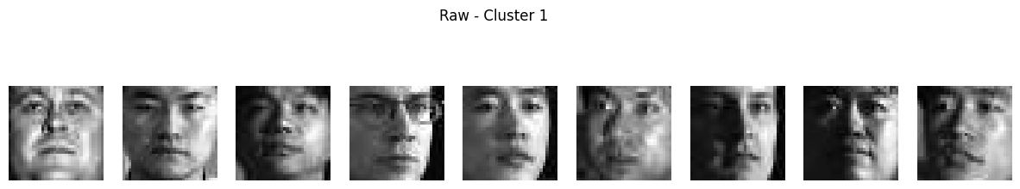
(b)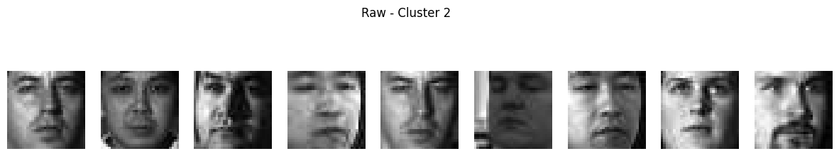
(c)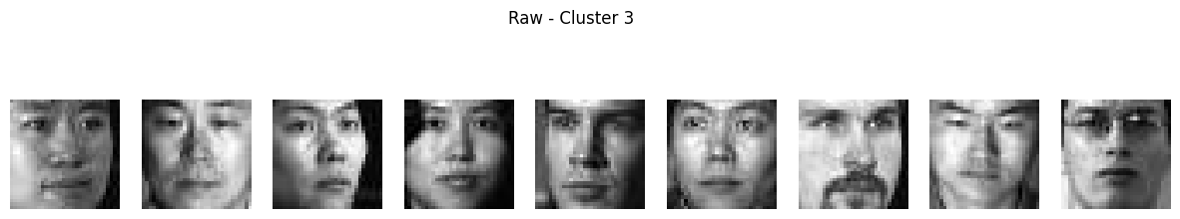
Figure 4.1 Raw image clusters
(a)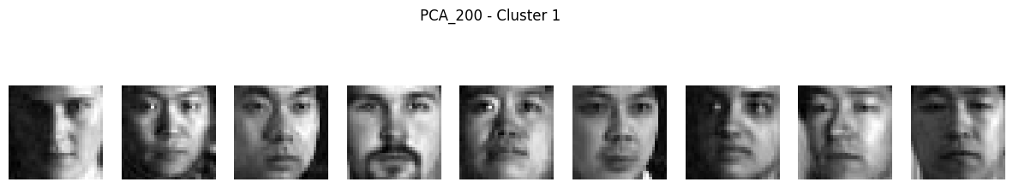
(b)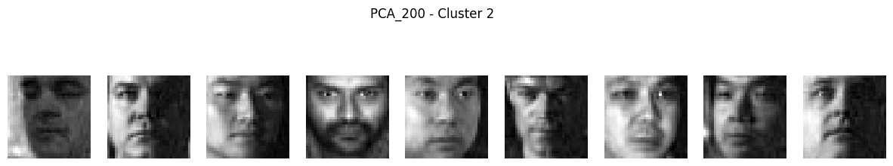
(c)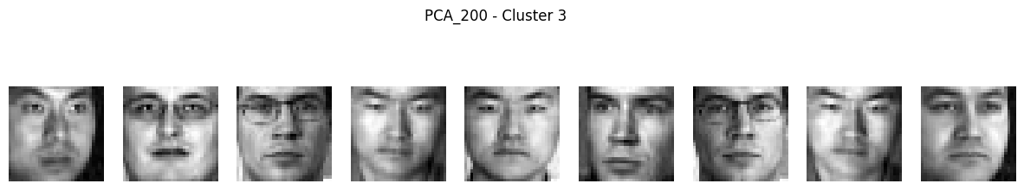
Figure 4.2 PCA_200 image clusters
(a)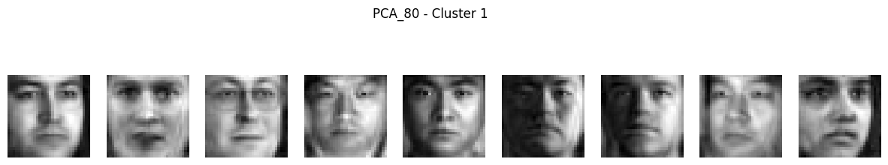

(b)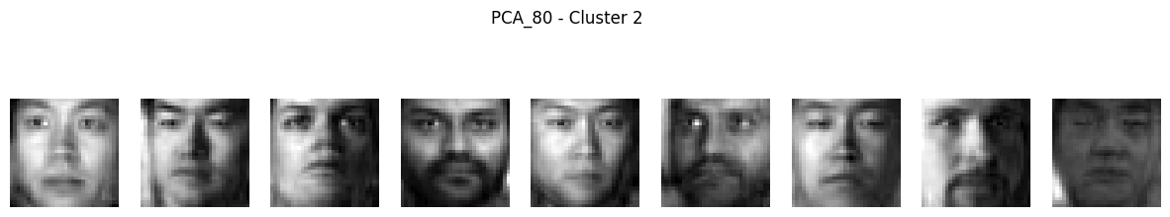
(c)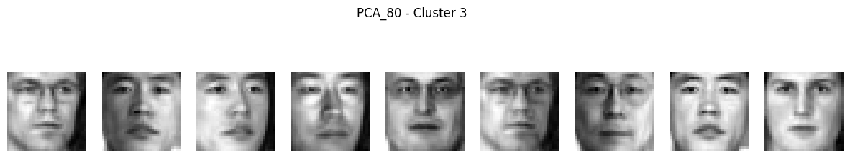
Figure 4.3 PCA_80 image clusters
A Gaussian Mixture Model is a probabilistic model that assumes the data is generated from a mixture of several Gaussian distributions, each representing a cluster within the data. In this part, each cluster represents a subgroup of images that share similar feature patterns. These clusters are not based on any predefined labels but rather on the statistical similarity within the dataset.
From the raw clusters, I can’t observe very clear similarities between the images within a cluster, especially in cluster 3, where all the faces, for human perception, don’t look alike. PCA_200 and PCA_80 exhibit more similarities compared to the raw clusters, however, faces still have differences. The lighting conditions also contribute to the clustering, a cluster is likely to have images with similar lighting. For example, in PCA_80-cluster 3, most of the faces are lightened. In raw clusters, each face image is represented by its raw vector. The clusters found by GMM on this data will group faces based on direct pixel intensity patterns. However, this is not so effective for clustering by facial features due to high dimensionality and pixel noise. After PCA, the images are represented in a lower-dimensional space that captures the principal components. This reduced feature space can capture essential features while ignoring minor details. GMM in this PCA space is more effective because the model can focus on key patterns instead of being overwhelmed by raw pixel noise.

5 Convolutional Neural Network
A Convolutional Neural Network (CNN) is utilized to classify the category of faces. CNN can automatically extract features from input images during training, eliminating the need to manually create feature extraction algorithms before passing the dataset into classifiers.
Combining the CMU PIE dataset with my selfies, 2082 training samples and 1278 testing samples are obtained. In this part, CNN is constructed with two convolutional layers with the ReLu activation function and a kernel size of 5×5, which are followed by max-pooling layers with a kernel size of 2×2 and a stride of 2, and one fully connected layer. The output layer is activated with the softmax function. The visualization of the network is shown in Figure 5.1.
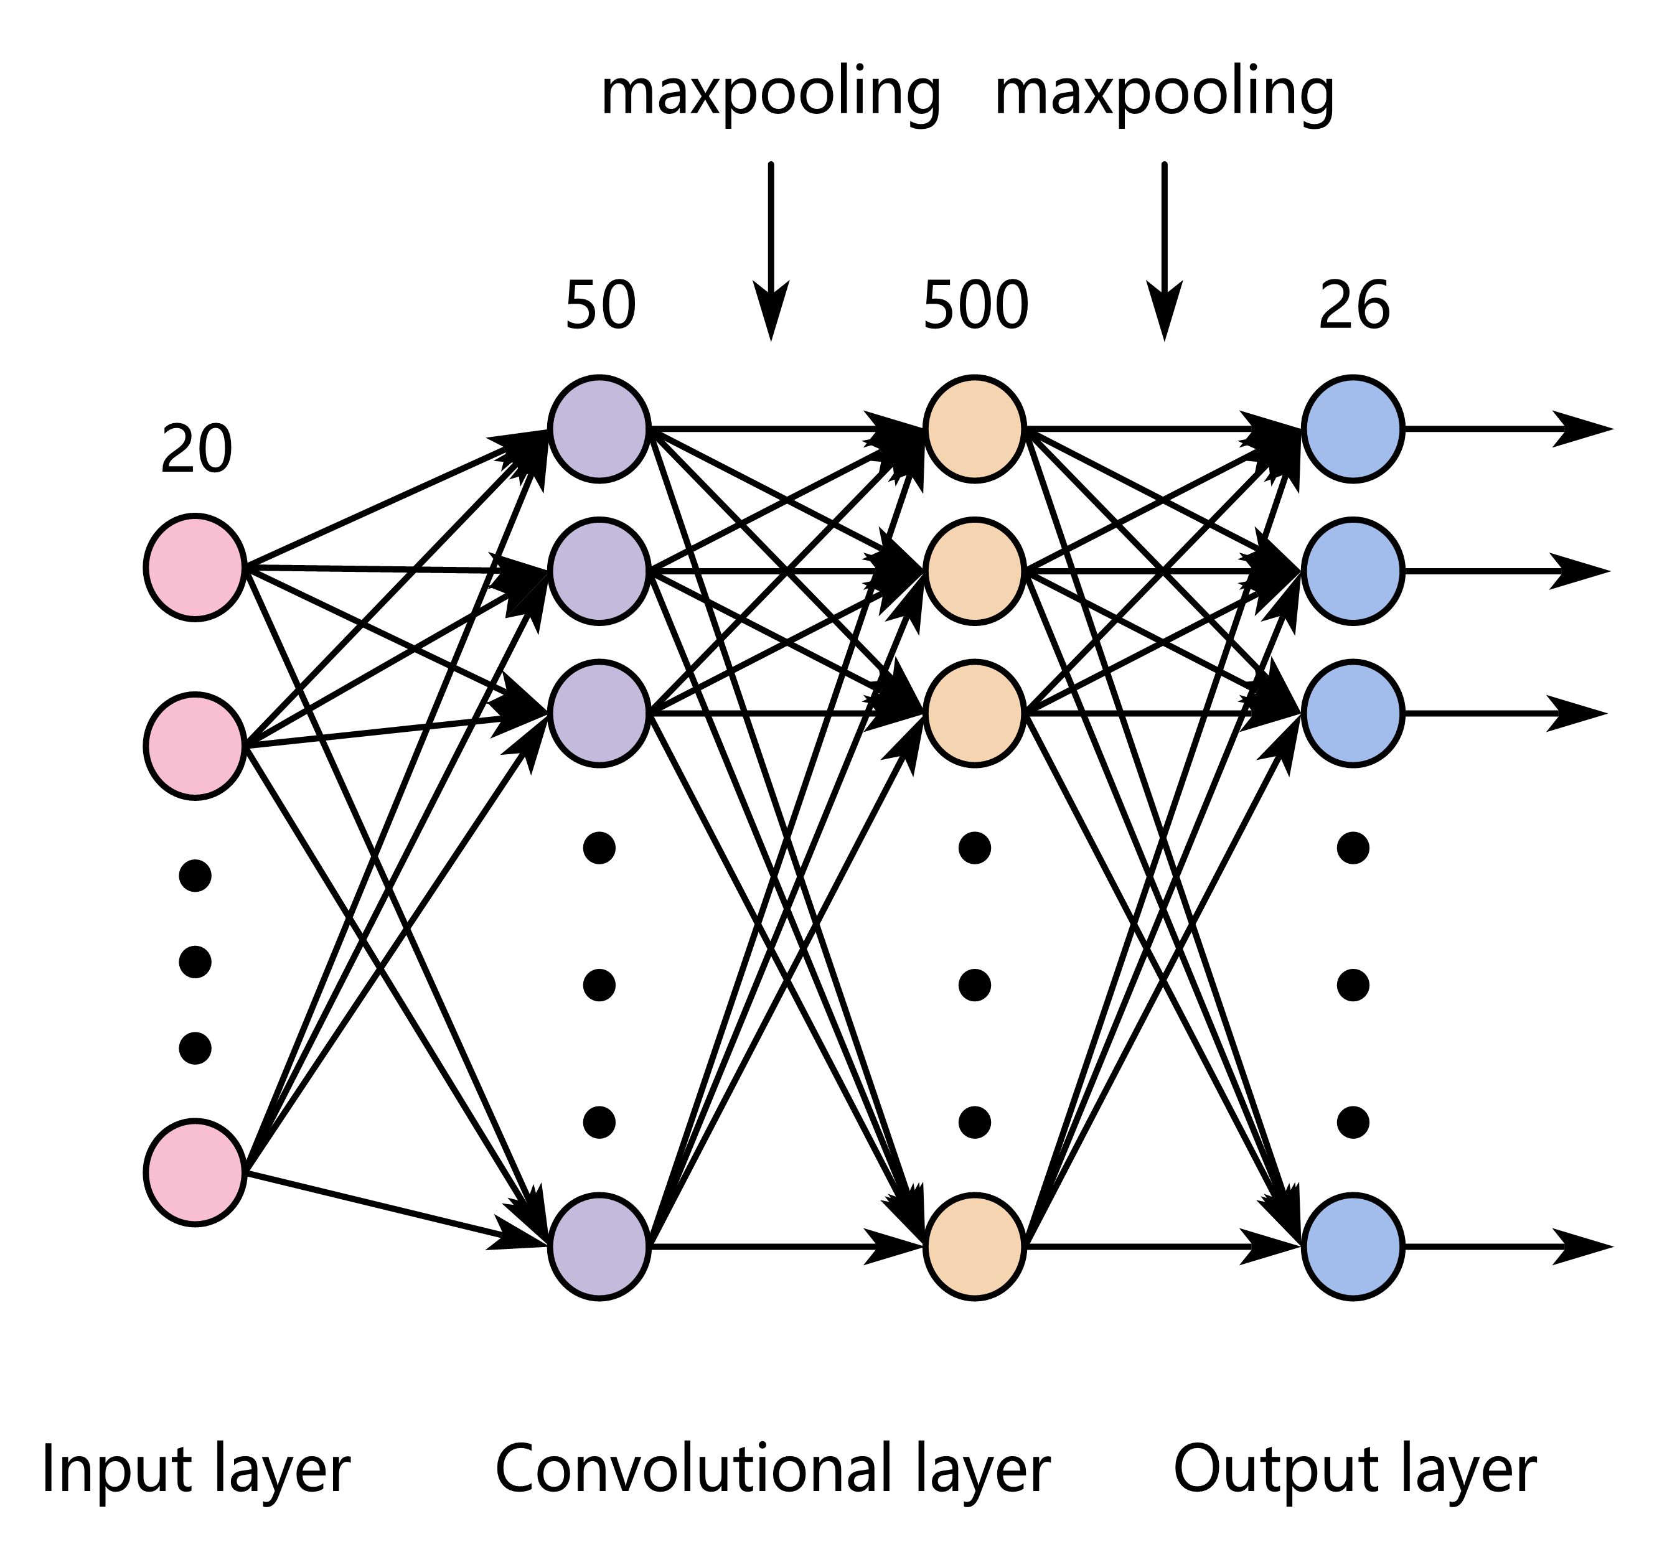
Figure 5.1 CNN structure
The model is trained for 25 epochs, and the batch size is 30. The cross-entropy loss is selected as the loss function, and the Adam optimizer is utilized for iteration. At each checkpoint, the model with the greatest validation accuracy is saved as the best model. Figure 5.2 illustrates the accuracy and loss for each epoch in the training stage. The classification performance on the test set is shown in Table 5.1.
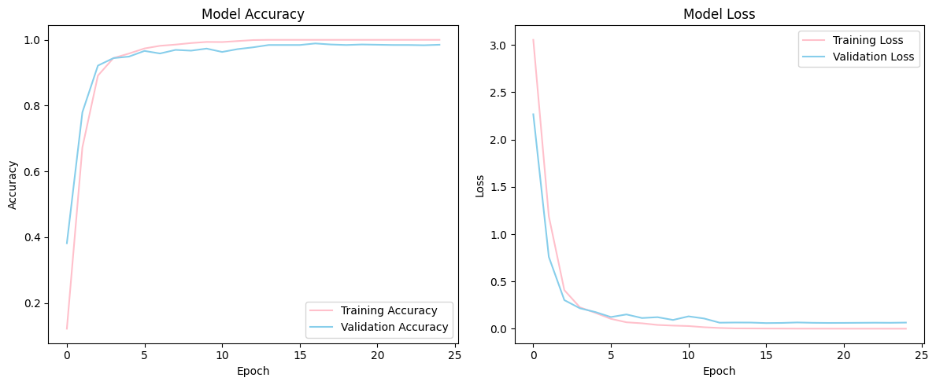
Figure 5.2 Accuracy and loss plots
Table 5.1 CNN classification performance
Dataset | Test Accuracy
Whole dataset | 98.51%
CMU-PIE | 98.51%
Selfie | 100%
The model achieves a rather high accuracy of 98.51% on the entire dataset, showing that this CNN effectively distinguishes between the classes in both the CMU-PIE and selfie subsets. This high performance suggests that the CNN architecture is well-suited to this dataset and can capture distinguishing features effectively. Moreover, the model achieves 100% accuracy on the selfie dataset, suggesting that the features of the selfie images are particularly distinct from those in the CMU-PIE dataset, making them easy for CNN to classify accurately. This implies that the selfie images have unique characteristics that set them apart from the other images in the dataset, allowing CNN to differentiate them without error. However, this perfect accuracy can also be attributed to the small size of the selfies. Overall, the fact that the model performs well across both datasets indicates that it generalizes well. It captures relevant features across different types of images (both selfies and images from CMU-PIE), showing robustness and adaptability to minor variations in the dataset.

6 Summary
This project leverages 4 methods to evaluate the performance of facial image classification. In PCA, the overall accuracy is beyond 90%, with a selfie’s accuracy of 100%. In LDA, the performance is slightly worse than PCA, however, after increasing the dimensions, CMU-PIE’s accuracy is also above 90%. In selfies, the accuracy is rather low with some 33.33%. In GMM, each dimension shows 3 Gaussian clusters, with different facial images. In CNN, a three-layer structure is implemented with the Relu activation function. Due to the black-box nature of the neural network, we can’t see what features the network has learned, however, classification results are rather considerable and achieve the highest among these methods with 98.51% for CMU-PIE and 100% for selfies.

